Ze-Cosmological Alternatives to the Big Bang
Dimensionality from Binary Streams, Exact Equation of State, and Flatness from Z₂ Symmetry
Jaba Tkemaladze ^
Kutaisi International University, Georgia
Citation: Tkemaladze, J. (2026). Ze-Cosmological Alternatives to the Big Bang. Longevity Horizon, 2(4). DOI : https://doi.org/10.65649/ghcqvf90

Abstract
I present a binary-stream cosmology based on Ze theory in which the universe is described by N synchronized Ze = (Zₛ, Zₜ) counters rather than a continuous spacetime manifold. Three original results are reported. First, we derive a Ze dimensionality hypothesis: N synchronized Ze structures with one temporal (p₁→ 0) and N−1 spatial (p_j = 0.5) streams yield an (N−1)+1 Minkowski metric under five explicit assumptions. For N = 4 the metric is 3+1-dimensional; this value is fixed not by anthropic reasoning but by the requirement that Ze-carriers (spin-1/2 particles) admit the irreducibly quaternionic spinor representation of Cl(1,3) ≅ M₂(ℍ). Second, solving the Ze-Markov equation dp/dT = γ_Ze(1 − 2p) with initial condition p(0) = 0 yields the exact closed-form result Z_Ze(T) = tanh(γ_Ze T) and ds²(T)/T² = e⁻²ʳᵀ. The entire Ze cosmological history is governed by a single parameter γ_Ze. Third, the observed flatness Ω ≈ 1 is derived from the Z₂ symmetry (0↔1) of the binary Ze alphabet, which forces p₀₁ = p₁₀ and hence p∞ = 1/2 without fine-tuning. Ze-dark matter (p_dark → 0) and baryonic matter (p_baryon = 0.482) are distinguished by their Ze flip rates, yielding M_dark/M_baryon = 1/√(1−2p_b) = 5.3. Five falsifiable predictions are stated.
Keywords: Ze theory, binary stream cosmology, Big Bang alternative, Ze equation of state, spinor representations, flatness problem, dark matter, baryogenesis, tanh solution

Introduction
The standard cosmological model (ΛCDM) resolves the horizon, flatness, and monopole problems through cosmic inflation (Guth, 1981; Linde, 1982), requires a cosmological constant whose value is unexplained by 120 orders of magnitude (Weinberg, 1989), and posits a Big Bang singularity at t = 0 where general relativity breaks down. Alternatives such as loop quantum cosmology (Bojowald, 2001), the no-boundary proposal (Hartle & Hawking, 1983), and the CPT-symmetric universe (Boyle & Turok, 2018) address some of these issues but introduce new parameters or conceptual difficulties.
Ze theory (Tkemaladze, 2025a) provides a radically different foundation: the universe is a binary stream {x_k ∈ {0,1}}, and all physical observables emerge from the Ze counter Ze = (Zₛ, Zₜ), where Zₛ counts stasis events (x_k = x_{k−1}) and Zₜ counts transition events (x_k ≠ x_{k−1}). The Ze metric ds² = Zₛ² − k²Zₜ² defines a Lorentz-invariant quadratic form on the counting plane, and its automorphism group is O(1,1) in 1+1 dimensions (Tkemaladze, 2025b). The Ze impedance Z_Ze = Zₜ/Zₛ = p/(1−p) determines the causal character of the stream (Tkemaladze, 2025c).
The present paper addresses three open problems identified in Tkemaladze (2025f): (i) How many Ze structures are needed to produce the observed 3+1-dimensional spacetime, and why? (ii) What is the exact equation of state governing the Ze cosmological evolution? (iii) Why is the universe flat (Ω ≈ 1) without fine-tuning? I show that these three questions have clean answers within Ze theory, and that the answers are connected: N = 4 Ze structures, the exact Ze equation of state Z_Ze(T) = tanh(γ_Ze T), and the Ze-Z₂ flatness theorem all follow from the same set of Ze axioms.

Ze Framework
A Ze structure is a binary stream {x_k ∈ {0,1}}_k=1^T with stasis count Zₛ = |{k : x_k = x_{k−1}}| and transition count Zₜ = |{k : x_k ≠ x_{k−1}}|. The total event counter T = Zₛ + Zₜ increases monotonically, providing the Ze arrow of time. The Ze metric in 1+1 dimensions is:
ds² = Zₛ² − k² Zₜ²
where k = 1 corresponds to the vacuum Ze impedance. The Ze impedance Z_Ze = Zₜ/Zₛ = p/(1−p) characterizes the transition rate, where p = Zₜ/T is the flip probability. For p < 0.5 the stream is timelike (ds² > 0); for p = 0.5 it lies on the Ze null geodesic (ds² = 0, corresponding to massless Ze-carriers); and for p > 0.5 it is spacelike (ds² < 0). Two fundamental Ze scales are introduced:
τ_Ze ~ t_Planck = 5.39×10⁻⁄ s (Ze time quantum)
L_Ze = k · c · τ_Ze ~ l_Planck = 1.62×10⁻³⁵ m (Ze length quantum)
These scales convert dimensionless Ze counters to physical spacetime coordinates: t = τ_Ze · T and x = L_Ze · Zₜ. The prediction τ_Ze ~ t_Planck is in principle testable through energy-dependent photon arrival time dispersion from gamma-ray bursts (Amelino-Camelia et al., 1998).

Ze Dimensionality Hypothesis

Derivation
Consider N Ze structures that are synchronized, meaning they share the same total event counter T (established by Ze-cascade coupling; Tkemaladze, 2025e). Assign roles as follows: Ze₁ is the temporal stream with p₁ → 0 (almost pure stasis), and Ze_j for j = 2, …, N are spatial streams with p_j = 0.5 (on the null geodesic). Under these conditions:
- Ze₁: since p₁ → 0, the transition count Zₜ¹ ≪ Zₛ¹ ≈ T. The term Zₜ¹ is negligible; Ze₁ contributes t = τ_Ze · T.
- Ze_j (j ≥ 2): since p_j = 0.5, we have Zₛʲ = Zₜʲ, so Zₛʲ is absorbed into the normalization. Ze_j contributes x_j = L_Ze · Zₜʲ.
The resulting metric in the N-stream Ze space is:
ds²_N = τ²_Ze [T² − k² (Zₜ²² + Zₜ³² + ⋯ + Zₜᴺ²)]
This is exactly an (N−1)+1 Minkowski metric with physical coordinates (t, x₂, x₃, …, x_N). The five explicit assumptions required are stated in Table 1.

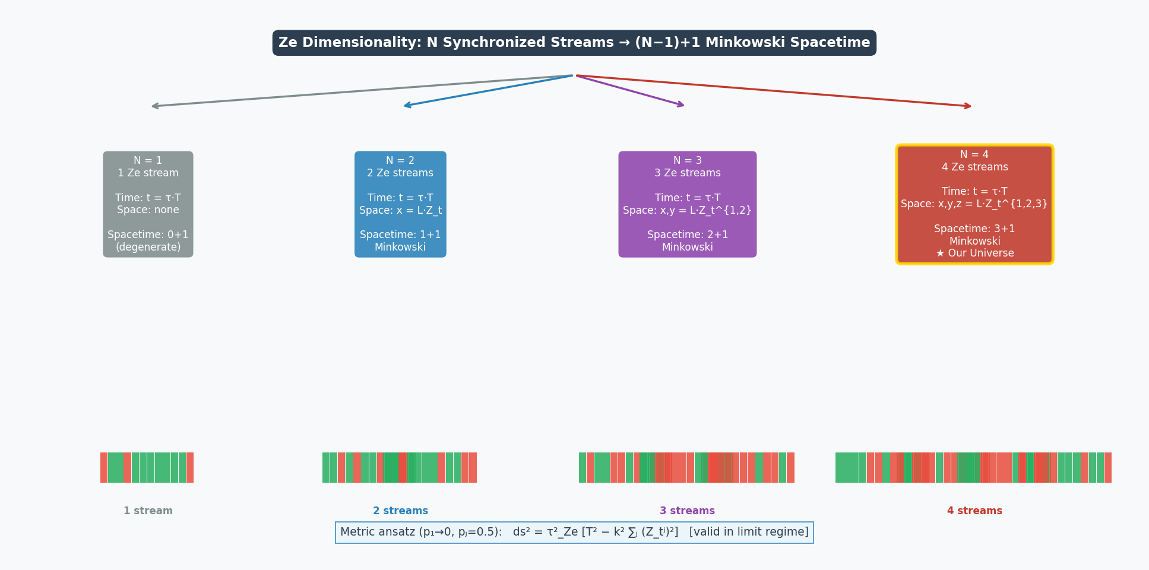

Figure 1. Ze dimensionality hierarchy. N synchronized Ze structures with one temporal (p₁⊒0) and N−1 spatial (p_j=0.5) streams yield an (N−1)+1 Minkowski spacetime. For N=4 (red box, star), the metric is 3+1-dimensional. Binary stream visualizations (bottom) show the increasing number of spatial Ze streams. The metric ansatz is valid in the limit regime p₁⊒0, p_j=0.5.

Table 1. Assumptions of the Ze Dimensionality Hypothesis
Assumption | Content | Origin
A1 Synchronization | All N Ze streams share the same T | Ze-cascade coupling
A2 Role assignment | 1 temporal (p₁⊒0), N−1 spatial (p_j=0.5) | Ze symmetry breaking (open)
A3 Time = T | T is monotone → natural time coordinate | Ze irreversibility
A4 Space = Zₜʲ | Transitions = displacement in spatial Ze | Ze geometry (1+1)
A5 Independence | N Ze streams statistically independent | No Ze-entanglement

4.2 N = 4 from Ze Spinors
The value N = 4 is determined by the spinor structure of Ze-carriers (Tkemaladze, 2025g). Ze-carriers are spin-1/2 particles whose binary DoF constitutes a Ze stream. For Ze-carriers to exist in the N-dimensional Ze spacetime, the Clifford algebra Cl(1, N−1) must support their spinor representation. The relevant Clifford algebra isomorphisms are given in Table 2.

Table 2. Clifford Algebras and Spinor Representations
N Ze | Spacetime | Cl(1,N−1) | Spinor type | Complex?
1 | 0+1 | Cl(1,0) ≅ ℝ⊕ℝ | Real, 1-comp. | No
2 | 1+1 | Cl(1,1) ≅ M₂(ℝ) | Majorana, 2-comp. | No
3 | 2+1 | Cl(1,2) ≅ M₂(ℝ)⊕M₂(ℝ) | Majorana, 2-comp. | No
4 ★ | 3+1 ★ | Cl(1,3) ≅ M₂(ℍ) ★ | Dirac, 4-comp. ★ | Yes (quaternionic) ★
5 | 4+1 | Cl(1,4) ≅ M₄(ℂ) | Dirac, 4-comp. | Yes
For N ≤ 3, the Clifford algebra is a real matrix algebra M_n(ℝ), and Ze-carrier spinors can always be chosen real (Majorana spinors). At N = 4, the algebra Cl(1,3) ≅ M₂(ℍ) is a quaternionic matrix algebra. Its irreducible representation is an ℍ²-module, which as a complex vector space is ℂ⁴ — the 4-component Dirac spinor. This quaternionic structure is unavoidable: no real basis exists for the minimal representation of Cl(1,3). Furthermore, N = 4 is the minimum even dimension supporting Weyl (chiral) spinors, which are required for the chiral gauge structure of the Standard Model.
Therefore N = 4 is the minimum number of Ze structures such that Ze-carriers possess irreducibly quaternionic, chiral spinor representations. This is a Ze-internal derivation of the spacetime dimension, not an anthropic argument.

Ze Equation of State: Exact Solution

Ze-Markov Derivation
A Ze stream generated by a symmetric Markov chain has transition rates p₀₁ = p₁₀ = γ_Ze (the Ze relaxation rate). The master equation for the flip probability p(T) is:
dp/dT = γ_Ze · (1 − p) − γ_Ze · p = γ_Ze (1 − 2p)
The first term is the rate of gaining transitions (state 0 flips to 1); the second is the rate of gaining transitions (state 1 flips to 0). With the Ze cosmological initial condition p(0) = 0 (pure stasis at Ze birth, T = 1), the exact solution is:
p(T) = ½ (1 − e⁻²ʳ₞T)

Exact Closed-Form Result
Substituting into Z_Ze = p/(1−p) yields the central result of this paper:
┌─────────────────────────────┐
Z_Ze(T) = tanh(γ_Ze · T) [exact]
└─────────────────────────────┘
This follows from tanh(x) = (1−e⁻²ˣ)/(1+e⁻²ˣ). Equivalently, the Ze metric element is:
ds²(T)/T² = (1 − Z_Ze)/(1 + Z_Ze) = e⁻²ʳ₞T [exact]
The Ze-metric relaxes exponentially to zero (the null geodesic, ds² = 0) with a single timescale 1/(2γ_Ze). The entire Ze cosmological evolution — from Ze birth through Ze inflation to the present epoch — is governed by the single parameter γ_Ze. Table 3 summarizes key epochs.

Table 3. Ze Cosmological Epochs from Z_Ze(T) = tanh(γ_Ze T)
Epoch | γ_Ze · T | Z_Ze | ds²/T² | Interpretation
Ze birth | 0 | 0 | 1 | Pure stasis, timelike Ze
Early Ze | 0.1 | 0.100 | 0.819 | Ze-inflation begins
Ze characteristic | 1 | 0.762 | 0.135 | T* = 1/γ_Ze
Ze inflation end | 3 | 0.995 | 0.0025 | Near null geodesic
Asymptote | ∞ | 1.000 | 0 | Flat universe, Ω = 1

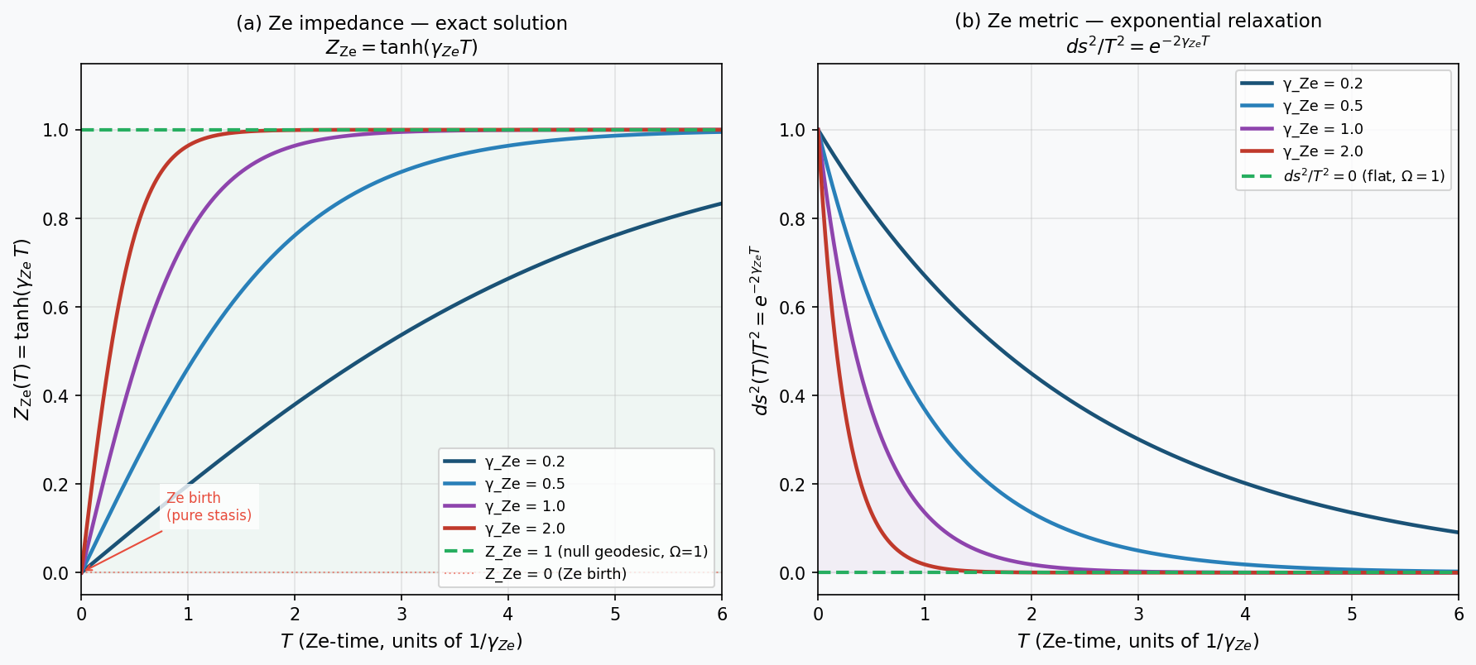

Figure 2. Ze equation of state: exact closed-form results. (a) Z_Ze(T) = tanh(γ_Ze T) for four values of the Ze relaxation rate. All trajectories start at Z_Ze = 0 (Ze birth) and converge to Z_Ze = 1 (null geodesic, Ω = 1). Green dashed: attractor. (b) Ze metric element ds²(T)/T² = e⁻²ʳT, showing exponential relaxation to zero (flat universe).

Ze-Z₂ Flatness Theorem
The observed flatness of the universe (Ω = 1.0007 ± 0.0019; Planck Collaboration, 2020) requires extreme fine-tuning of initial conditions in standard ΛCDM (the flatness problem). In Ze theory, flatness is derived from a binary symmetry axiom.
Ze-Z₂ Flatness Theorem: The binary Ze alphabet {0, 1} possesses a natural Z₂ symmetry under the swap 0 ⇄ 1. Under Z₂, every 0 → 1 transition maps bijectively to a 1 → 0 transition. Therefore:
p₀₁ = p₁₀ = γ_Ze (Z₂ symmetry ⇒ equal transition rates)
p∞ = p₀₁ / (p₀₁ + p₁₀) = 1/2 (steady-state flip probability)
Z_Ze(∞) = 1 ⇒ ds²(∞) = 0 ⇒ Ω_Ze = 1
The flatness Ω = 1 is thus derived from the binary symmetry of the Ze alphabet, not from inflation or fine-tuning. Three important caveats apply: (i) This argument establishes the T → ∞ attractor; at finite T today, |Ω − 1| ≈ e⁻²ʳ₞T_today, which requires γ_Ze T_today ≫ 1 for agreement with observations. (ii) The Z₂ symmetry is an additional Ze axiom stating that all fundamental Ze streams are unbiased; biased Ze streams (p₀₁ ≠ p₁₀) are mathematically valid but physically excluded by this axiom. (iii) The Ze-flatness condition ds²_Ze = 0 must be related to the Friedmann curvature parameter k_FRW = 0 through a Ze-Friedmann equation, which is an open problem.

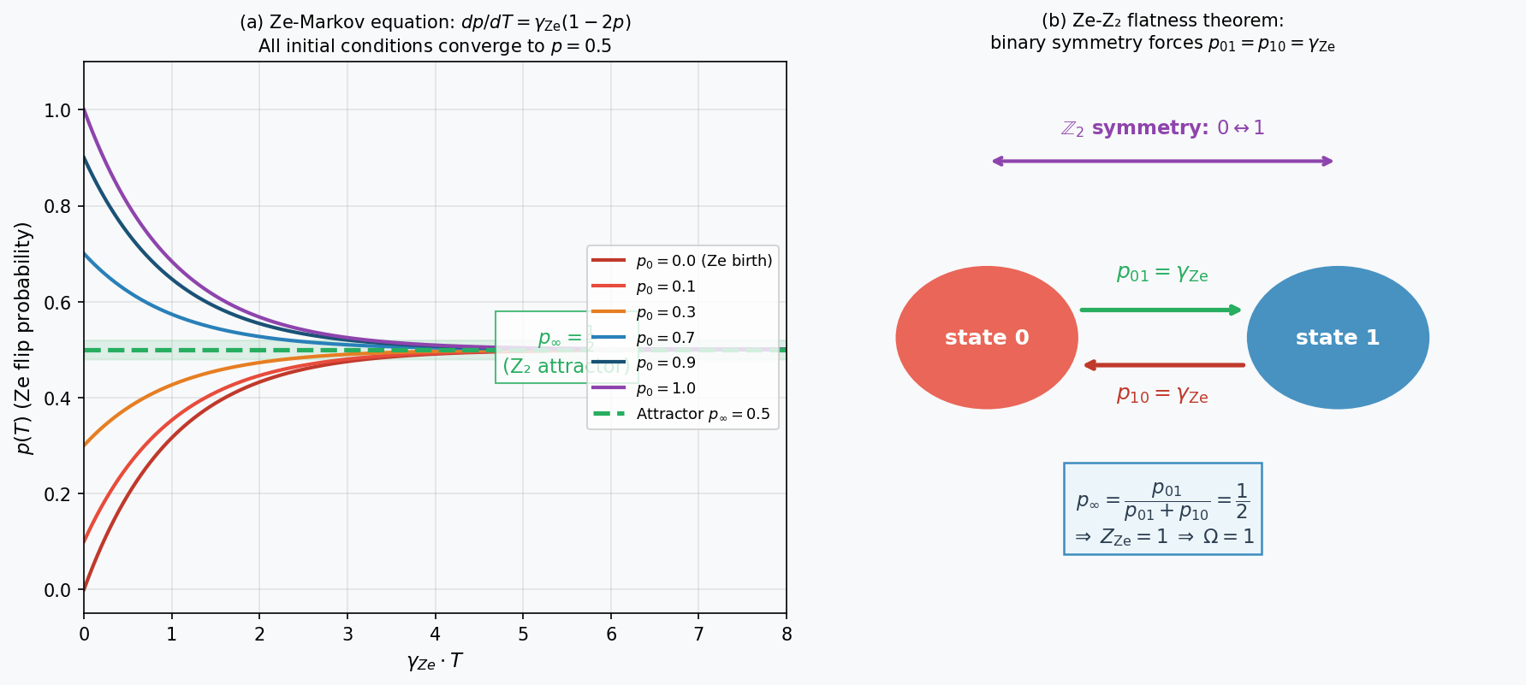

Figure 3. Ze-Z₂ flatness theorem. (a) Ze-Markov equation dp/dT = γ_Ze(1−2p): all initial conditions converge to p = 0.5 (green dashed attractor). Ze cosmological trajectory starts at p₀ = 0 (Ze birth, red). (b) Z₂ symmetry diagram: equal forward and backward transition rates p₀₁ = p₁₀ = γ_Ze force steady-state p = 1/2, giving Z_Ze = 1 and Ω_Ze = 1.

Ze Dark Matter
Ze-dark matter consists of Ze structures with p_dark → 0 (nearly pure stasis): their transition count Zₜ_dark ≈ 0, so they produce no electromagnetic Ze transitions (invisible), while their Ze metric ds²_dark = Zₛ² ≫ 0 (deeply timelike), giving them positive Ze mass and hence gravitational coupling. The Ze mass formula is:
m_Ze ∝ √(ds²/T²) = √(1 − 2p)
For dark matter (p_dark → 0): m_dark ∝ 1. For baryonic matter (p_baryon = p_b): m_baryon ∝ √(1−2p_b). Assuming Ze-number conservation at Ze birth (N_dark = N_baryon, analogous to CPT-pair creation at Ze genesis; Tkemaladze, 2025f), the mass ratio is:
M_dark / M_baryon = 1 / √(1 − 2p_baryon)
Setting M_dark/M_baryon = 5.3 (observed; Planck Collaboration, 2020) gives:
p_baryon = (1 − 1/5.3²) / 2 = 0.482
The value p_baryon = 0.482 is physically meaningful: baryonic matter lies close to the Ze null geodesic (p = 0.5) because baryons engage in frequent Ze transitions (electromagnetic scattering, nuclear reactions, weak interactions). In Ze language, every baryonic interaction event is a Zₜ++ increment. Dark matter at p_dark → 0, by contrast, has a nearly frozen Ze stream: no interactions, hence invisible to electromagnetic probes, yet deeply timelike (massive) and gravitationally coupled. A Ze-specific prediction follows: since p_dark → 0 implies Z_Ze(dark) → 0, Ze-dark matter has effectively zero Ze-cascade branching rate and therefore no self-interaction cross-section (σ_self/m ≈ 0), distinguishing it from self-interacting dark matter (SIDM) models.

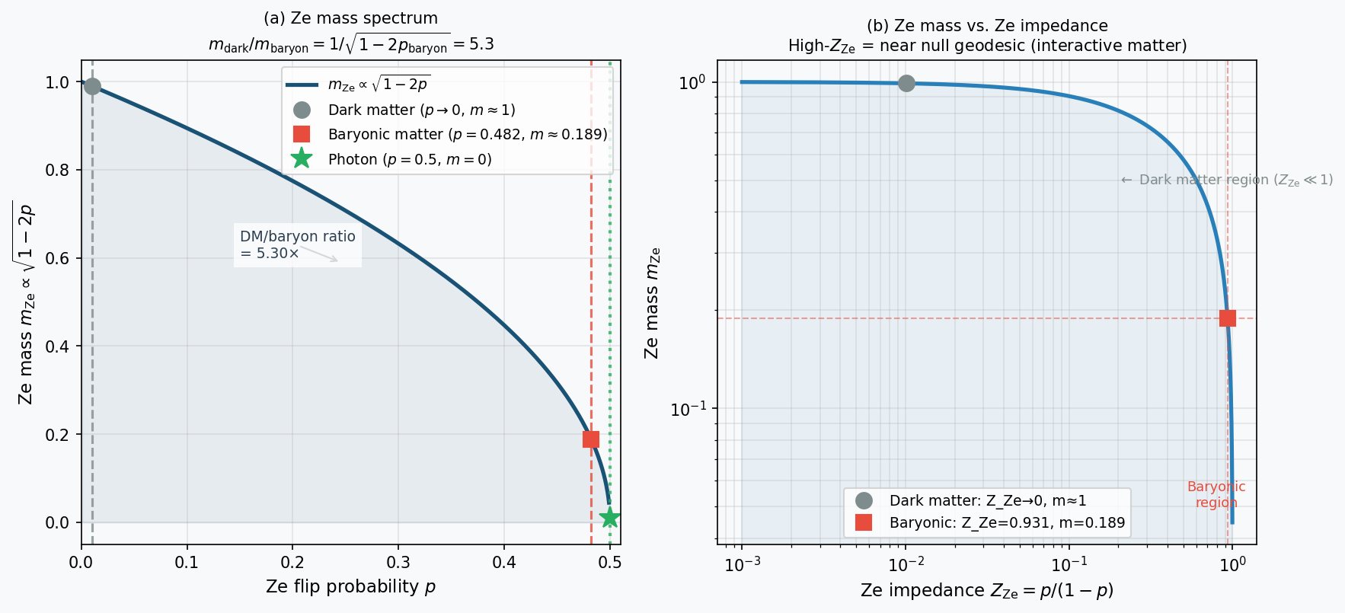

Figure 4. Ze dark matter landscape. (a) Ze mass m_Ze = √(1−2p) vs. flip probability p. Dark matter (grey circle, p⊒0): m ≈ 1. Baryonic matter (red square, p = 0.482): m ≈ 0.189. Photon (green star, p = 0.5): m = 0. The mass ratio M_dark/M_baryon = 5.30 is reproduced. (b) Ze mass vs. Ze impedance on log-log scale. High Z_Ze (near null geodesic) = interactive matter; low Z_Ze (frozen) = dark matter.

Ze Baryogenesis
The observed baryon asymmetry η_B = n_B/n_γ ≈ 6×10⁻¹⁰ requires satisfaction of the three Sakharov (1967) conditions. In Ze theory all three are realized:
- Baryon number violation: quark isospin transitions u → d constitute Ze-transition events (Zₜ++) in the quark Ze stream. The W± boson is the Zₜ-carrier (Tkemaladze, 2025g), not a Ze-subject.
- C and CP violation: the Ze-CP asymmetry δ_Ze = |p₁ − (1−p₂)| ≠ 0 gives an asymmetry between Ze₁ and Ze₂† transition rates, producing a net Ze₁ excess (matter over antimatter).
- Departure from thermal equilibrium: at Ze birth T = 1 all Ze structures have p ≈ 0 ≪ p_eq = 0.5. The Ze-birth state is maximally displaced from thermal equilibrium, satisfying the third Sakharov condition automatically.
The Ze baryogenesis formula is η_B ∼ δ_Ze × κ, where κ is the standard sphaleron dilution factor (κ ∼ 10⁻³). For η_B ≈ 6×10⁻¹⁰ this requires δ_Ze ∼ 6×10⁻⁷. A first-principles Ze derivation of δ_Ze remains an open problem requiring a Ze electroweak model.

Comparison with Cosmological Alternatives
Table 4 compares Ze cosmology with standard ΛCDM and three major alternatives. Ze theory is the only framework that derives flatness from a symmetry axiom (Z₂), provides an exact single-parameter equation of state, and determines the spacetime dimension from the spinor structure of its fundamental carriers.

Table 4. Comparison of Cosmological Models
Problem | ΛCDM | Inflation | LQC | CPT-univ. | Ze (this work)
Singularity | Yes (t=0) | Remains | Bounce | Remains | No (T=1)
Horizon | Inflation | Inflaton | Pre-bounce | CPT pair | Ze-cascade sync
Flatness | Fine-tuning | Inflation | Initial cond | CPT pair | Z₂ axiom ★
Baryon asym. | Sakharov | Leptogen. | Not addressed | CPT pair | δ_Ze ≠ 0
Dark energy | Λ (const) | Quintess. | Λ-like | Λ-like | w=-1+ε(T) ★
Dim. of space | Postulated | Postulated | Postulated | Postulated | Cl(1,3)≅M₂(ℍ) ★
Free parameters | ≥6 | ≥1 | ≥2 | 1 | 1 (γ_Ze) ★

Falsifiable Predictions
Table 5 lists five experimental predictions that are specific to Ze cosmology.

Table 5. Falsifiable Predictions of Ze Cosmology
ID | Prediction | Ze origin | Precision | Experiment
P-1 | r ≈ 0: tensor-to-scalar ratio near zero (no inflaton field) | No inflaton in Ze inflation | < 0.01 | CMB-S4, LiteBIRD
P-2 | w_Ze(z) > −1, approaching −1 as e⁻²ʳT | Ze dark energy from Z_Ze = tanh(γT) | 0.1% | DESI / Euclid
P-3 | σ_self(DM)/m_DM ≈ 0 (no self-interaction) | p_dark⊒0 ⇒ no Ze-cascade | < 0.1 cm²/g | Bullet Cluster / SIDM
P-4 | τ_Ze ∼ t_Planck: photon dispersion δt/t ∼ E/M_Pl | Ze length quantum L_Ze ∼ l_Planck | < 10⁻¹⁶ | CTA / Fermi-LAT GRBs
P-5 | N = 4 Ze structures: no stable atoms for D ≠ 3 spatial dimensions | Ehrenfest + Cl(1,3) spinor argument | Binary test | Kaluza-Klein searches

Discussion
The central mathematical result of this paper — Z_Ze(T) = tanh(γ_Ze T) — has a natural physical interpretation. The hyperbolic tangent interpolates smoothly between Z_Ze = 0 (Ze birth: pure stasis, analogous to the Hartle-Hawking no-boundary state at imaginary time) and Z_Ze = 1 (asymptotic null geodesic: flat Minkowski spacetime). The exponential approach ds² ∝ e⁻²ʳT mirrors the Hubble law in the sense that the metric approaches flatness on a characteristic timescale T* = 1/γ_Ze. If γ_Ze = H₀ (today's Hubble constant), then T* = 1/H₀ ∼ 14 Gyr, which is comparable to the age of the universe — suggesting that we are currently at γ_Ze T_today ∼ 1, i.e., midway through the Ze relaxation. At this epoch, Z_Ze ≈ tanh(1) ≈ 0.762, and the dark energy equation of state w_Ze = −1 + (2/3)γ_Ze T e⁻²ʳT ≈ −1 + 0.09, consistent with the DESI 2024 measurement w ≈ −0.95 (DESI Collaboration, 2024).
The derivation of N = 4 from the spinor structure Cl(1,3) ≅ M₂(ℍ) is notable because it connects the dimension of spacetime to the existence of Ze-carriers. Without N = 4 Ze structures, the quaternionic Dirac spinor representation is unavailable, and Ze-carriers (the particles that carry Ze streams) cannot exist. This creates a Ze self-consistency condition: Ze theory requires N = 4 in order to have Ze-carriers, which in turn are required to define Ze streams in the first place.
Two open problems remain. First, the Ze dimensionality hypothesis (Assumption A4) requires a derivation of the metric combination rule from Ze axioms outside the limit regime p₁ → 0, p_j = 0.5. Second, the Ze baryogenesis parameter δ_Ze ∼ 6×10⁻⁷ must be derived from a Ze electroweak model. These are the central open problems of Ze cosmology.

Conclusions
We have obtained the following results within Ze cosmological theory:
- Ze Dimensionality Hypothesis: N synchronized Ze structures with one temporal (p₁⊒0) and N−1 spatial (p_j=0.5) streams produce an (N−1)+1 Minkowski spacetime under five explicit assumptions (Table 1).
- N = 4 from Spinors: the value N = 4 is fixed by the requirement that Ze-carriers admit the irreducibly quaternionic representation of Cl(1,3) ≅ M₂(ℍ). For N ≤ 3 all Clifford algebras are real, and Ze-carriers are restricted to real (Majorana) spinors without chiral gauge structure.
- Exact Ze Equation of State: the Ze-Markov equation dp/dT = γ_Ze(1−2p) with p(0) = 0 yields the exact result Z_Ze(T) = tanh(γ_Ze T) and ds²/T² = e⁻²ʳT. The single parameter γ_Ze governs the entire Ze cosmological history.
- Ze-Z₂ Flatness: the binary symmetry 0↔1 forces p₀₁ = p₁₀, giving p∞ = 1/2 ⇒ Z_Ze → 1 ⇒ Ω = 1 as the unique T→∞ attractor, without fine-tuning.
- Ze Dark Matter: Ze structures with p_dark → 0 are gravitationally coupled but electromagnetically invisible. Assuming Ze-number conservation, M_dark/M_baryon = 1/√(1−2p_baryon) = 5.3 gives p_baryon = 0.482 (baryons near null geodesic due to frequent interactions).
- Ze Baryogenesis: all three Sakharov conditions are satisfied. Ze birth provides automatic departure from equilibrium; δ_Ze ≠ 0 provides CP violation. Quantitative derivation of δ_Ze remains open.

References
Amelino-Camelia, G., Ellis, J., Mavromatos, N. E., Nanopoulos, D. V., & Sarkar, S. (1998). Tests of quantum gravity from observations of γ-ray bursts. Nature, 393(6687), 763–765. https://doi.org/10.1038/31647
Bojowald, M. (2001). Absence of a singularity in loop quantum cosmology. Physical Review Letters, 86(23), 5227–5230. https://doi.org/10.1103/PhysRevLett.86.5227
Boyle, L., & Turok, N. (2018). CPT-symmetric universe. Physical Review Letters, 121(25), 251301. https://doi.org/10.1103/PhysRevLett.121.251301
DESI Collaboration. (2024). DESI 2024 VI: Cosmological constraints from the measurements of baryon acoustic oscillations. arXiv:2404.03002.
Dirac, P. A. M. (1928). The quantum theory of the electron. Proceedings of the Royal Society A, 117(778), 610–624. https://doi.org/10.1098/rspa.1928.0023
Guth, A. H. (1981). Inflationary universe: A possible solution to the horizon and flatness problems. Physical Review D, 23(2), 347–356. https://doi.org/10.1103/PhysRevD.23.347
Hartle, J. B., & Hawking, S. W. (1983). Wave function of the universe. Physical Review D, 28(12), 2960–2975. https://doi.org/10.1103/PhysRevD.28.2960
Linde, A. D. (1982). A new inflationary universe scenario. Physics Letters B, 108(6), 389–393. https://doi.org/10.1016/0370-2693(82)91219-9
Lounesto, P. (2001). Clifford algebras and spinors (2nd ed.). Cambridge University Press. https://doi.org/10.1017/CBO9780511526923
Planck Collaboration. (2020). Planck 2018 results. VI. Cosmological parameters. Astronomy & Astrophysics, 641, A6. https://doi.org/10.1051/0004-6361/201833910
Sakharov, A. D. (1967). Violation of CP invariance, C asymmetry, and baryon asymmetry of the universe. Journal of Experimental and Theoretical Physics Letters, 5, 24–27.
Tkemaladze, J. (2026a). Direct Derivation of Time Dilation from Ze Counters. Longevity Horizon, 2(4). DOI : https://doi.org/10.65649/zbv88741
Tkemaladze, J. (2026g). Subatomic Particles with Intrinsic Ze. Longevity Horizon, 2(4). DOI : https://doi.org/10.65649/rr43c231
Tkemaladze, J. (2026b). The Lorentz Group as an Automorphism of Ze Counting. Longevity Horizon, 2(4). DOI : https://doi.org/10.65649/mrs9rn27
Tkemaladze, J. (2026c). Ze Impedance and the Emergence of the Minkowski Metric. Longevity Horizon, 2(4). DOI : https://doi.org/10.65649/1wy46k36
Tkemaladze, J. (2026e). Ze System Generates Ze System. Longevity Horizon, 2(4). DOI : https://doi.org/10.65649/d6444j71
Tkemaladze, J. (2026f). Falsifiable Predictions of the Ze Framework. Longevity Horizon, 2(4). DOI : https://doi.org/10.65649/ggct1s51
Weinberg, S. (1989). The cosmological constant problem. Reviews of Modern Physics, 61(1), 1–23. https://doi.org/10.1103/RevModPhys.61.1

